# VISVESVARAYA TECHNOLOGICAL UNIVERSITY

# "Jnana Sangama", Belgaum -590 018, Karnataka State, India



A MINI PROJECT REPORT

ON

**“COURIER MANAGEMENT SYSTEM”**

Submitted on partial fulfilment of academic requirement of 5th semester

**DATABASE MANAGENENT SYSTEM LABORATORY**

**BACHELOR OF ENGINEERING**

**IN**

**COMPUTER SCIENCE AND ENGINEERING**

**Submitted by**

**SHRISHTI SHREYA**

. V SEM, CSE B .

USN: 1SJ17CS083

**Under the guidance of**

**Mr. SESHAIAH M**

Assistant Professor,

Department of CSE,SJCIT

**Carried out**

**at**

**DATABASE MANAGEMENT SYSTEM LABORATORY,**

**SJCIT**



**S J C INSTITUTE OF TECHNOLOGY**

**Department of Computer Science and Engineering**

**Chickaballapur – 562 101**

**2019-2020**

**|| Jai Sri Gurudev ||**

**Sri Adichunchanagiri Shikshana Trust**

**S.J.C INSTITUTE OF TECHNOLOGY**

**Computer Science & Engineering Department**

**Chickballapur-562101**



**CERTIFICATE**

This is to certify that the Project work entitled **“ COURIER MANAGEMENT SYSTEM”** is a bonafide work carried out at Database Management System Laboratory by SHRISHTI SHREYA**(1SJ17CS083)** in partial fulfilment for the award of **Bachelor of Engineering in Computer Science and Engineering in Fifth semester of the Visvesvaraya Technological University**, Belgaum during the year 2019-20.It is certified that all corrections/suggestions indicated for Internal Assessment have been incorporated in the report deposited in the department library. The project report has been approved as it satisfies the academic requirements in respect to Fifth Semester Mini Project work prescribed for the said degree.

**Signature of the Guide Signature of the HOD**

**Mr. Seshaih M Dr. Anitha T.N.**

**Assistant Professor, Professor and HOD,**

**Department of CS&E,SJCIT Department of CS&E,SJCIT**

**External Viva:**

**Name of Examiners**

**1)**

**2)**

**ACKNOWLEDGEMENT**

With Great pride I would like to convey my gratitude and appreciation to my alma-mater **“S.J.C Institute of Technology”** for giving me the required platform for the fulfilment of the Mini project on Database Management System as per the V.T.U requirements, for the fifth semester lab.

I express my sincere thanks to **Dr. K M Ravikumar,** Principal of **SJCIT** for providing me with excellent infrastructure and facilities to complete the project.

I express wholehearted gratitude to **Dr. T.N. Anitha** Professor and **HOD of Computer Science and Engineering Department**. I wish to acknowledge her help in making my task easy by providing me with her valuable help and encouragement.

It is my pleasure to thank my guides **Mr. Seshaiah M., Assistant Professor, Department of Computer Science and Engineering,** SJCIT for his guidance, encouragement and valuable suggestion from the beginning of the project work till the completion without which this project work would not have been accomplished. I am greatly indebted to them.

And last but not the least; I would be very pleased to express my heart full thanks to the teaching and non-teaching staff of the Department of Computer Science and Engineering, SJCIT for their motivation and support.

We also thank all those who extended their support and co-operation while bringing out this project.

**SHRISHTI SHREYA 1SJ17CS083**

**ABSTRACT**

This project mainly aims in the process of “Courier Management System” which deals with the Courier Information System. The system is used for daily activities such as booking a courier, maintain employee details, maintain customer details, maintain shipping details etc. It is very difficult to do this process manually. Hence it is recommended to computerize the process by developing the relative software as the world is turning into information and technology, computerization becomes necessity in all walks of life.

**TABLE OF CONTENTS**

ABSTRACT i

ACKNOWLEDGEMENT ii

CONTENTS iii-iv

LIST OF FIGURES v

**Chapter 1: Introduction 1**

* 1. Introduction to Project 1

1.2 Statement of the Project 1

1.3 Scope of the Project 1

**Chapter 2: System Requirements 2**

2.1 Hardware Requirements 2

2.2 Software requirements 2

**Chapter 3: Design 3**

3.1 Data flow Diagram 4

**Chapter 4: Implementation 5**

4.1Algorithm 5

4.2 Source Code 5

4.3 Snapshot 19

**Chapter 5: Conclusion 25**

**References 26**

**LIST OF FIGURES**

**Figure Number Figure Name Page Number**

Figure 4.1 ER Diagram 10

Figure 5.1 Customer Login 19

Figure 5.2 Customer Registration 19

Figure 5.3 Admin Login 20

Figure 5.4 Admin Registration 20

Figure 5.5 Customer Services 21

Figure 5.6 Admin Services 21

Figure 5.7 Admin Services 22

Figure 5.8 Customer Details 22

Figure 5.9 Delivery Details 23

Figure 5.10 Delete Customer 23

Figure 5.11 Staff Details 24

Figure 5.12 Database Information 24

**CHAPTER 1**

**INTRODUCTION**

* 1. **Introduction to Project**

The Project entitled “Courier Management System” is to develop a software product that is used in courier service to maintain their details systematically. The product is developed to maintain the sender and the receiver details, and also to get the information of the status of the courier..The main benefit of this project is that it facilitate user to communicate in a faster manner in comparison of manual system. Through this system the current status of the courier can be known easily whereas in manual system it is a difficult task. The Administrator department has all rights to provide or restrict to any department or employee to the functionality of the project. The working department will enter the information of the new courier into the data base. This Project facilitates to make calculation of the amount for sending a courier on the basis of the destination. The project is reliable only when the database is maintained properly.

* 1. **Statement of the Project**

The system will be used for day to day activities like out return, company details, booking. Actually it is not easy to do this process manually because it would become very hectic. Hence it is recommended to automate the process by developing the relevant software as the world is moving from manual working to information and technology era where computerization becomes important in all part of life. Product Description Courier Management System is a modular full business software framework for an enterprise which posses operations in domestic and international courier services. Courier Management System performs a variety of activities pertaining to the processes in the logistic context of a courier business. Courier Management System solution handles the end to end process staring from initiating a courier order, driver pickup and delivery of a courier business. Courier Management System covers all the controls and processes involved in International Courier Import Services, International Courier Export Services and Domestic Pickup & Delivery.

* 1. **Scope of the Project**

Courier management computerization is “the incorporate of appropriate technology to help administrator manage information. Technology is considered appropriate, when it utilizes the most abundant domestic resources and conserves capital and skilled personnel”.

This project deals with the maintenance of booking details, incoming courier details, courier non delivery details and courier return details etc; the main aim of this project is to computerize the maintenance of courier management.

**CHAPTER 2**

**SYSTEM REQUIREMENTS SPECIFICATION**

System requirement specification (SRS) is basically an organization, which understands a customer or potential client’s system requirements and dependencies at a particular point in time prior to any actual design or development work. It’s a two-way insurance policy that assures that both the client and the organization understand the others requirements from that perspective at a given point in time.

**3.1 HARDWARE REQUIREMENTS**

* PROCESSOR : INTEL I5
* RAM : 4GB
* HARD DISK SPACE : 500GB
* MOUSE AND KEYBOARD

**3.2SOFTWARE REQUIREMENTS**

* IDE : NETBEANS
* SERVER :Xampp
* OPERATING SYSTEM : Windows 10
* DATABASE : MYSQL
* FRONT END : JAVA

CHAPTER 3

**DESIGN**

The process of design involves “conceiving and planning out in mind and making a drawing, pattern or a sketch”. The system design transforms a logical representation of what a given system is required to do into the physical reality during development. Important design factors such as reliability, response time, throughput of the system, maintainability, expandability etc., should be taken into account. Design constraints like cost, hardware limitations, standard compliance etc should also be dealt with. The task of system design is to take the description and associate with it a specific set of facilities-men, machines (computing and other), accommodation, etc., to provide complete specifications of a workable system.

This new system must provide for all of the essential data processing and it may also do some of those tasks identified during the work of analysis as optional extras. It must work within the imposed constraints and show improvement over the existing system. At the outset of design a choice must be made between the main approaches. Talks of “preliminary design” concerned with identification analysis and selections of the major design options are available for development and implementation of a system. These options are most readily distinguished in terms of the physical facilities to be used for the processing who or what does the work.

**CHAPTER 4**

**IMPLEMENTATION**

Implementation is the action that must follow any preliminary thinking in order for something to actually happen. In an information technology context, implementation encompasses all the processes involved in getting new software or hardware operating properly in its environment, including installation, configuration, running, testing, and making necessary changes. The word deployment is sometimes used to mean the same thing.

Implementation is the realization of an application, or execution of a plan, idea, model, design, specification, standard, algorithm, or policy. In computer science, an implementation is a realization of a technical specification or algorithm as a program, software component, or other computer system through programming and deployment. Many implementations may exist for a given specification or standard.

The implementation stage in a system involves:

* Careful planning.
* Investigation of the current system and the constraints on implementation.
* Training of staff in the newly developed system.

Implementation is the stage of the project when the theoretical design is turned out into a working system. Thus it can be considered to be the most critical stage in achieving a successful new system and is giving the user, confidence that the new system will work and be effective. The implementation stage involves careful planning, Investigation of the existing system and its constraints on implementation, designing of methods to achieve change over and evaluation of change over methods.

**5.1 ALGORITHM**

**Step1:** Start.

**Step2:** Signup/Login to the Admin Panel.

**Step3:** Admin can add categories and packages.

**Step4:** Opening the Courier Management System.

**Step5:** User can login/register for access to services.

**Step6:** Book and View orders.

**Step7:** End

**5.2 SOURCE CODE**

import java.awt.Dimension;

import java.awt.Toolkit;

import java.sql.DriverManager;

import javax.swing.JOptionPane;

import java.beans.Statement;

import java.sql.Connection;

import java.sql.PreparedStatement;

import java.sql.ResultSet;

import java.sql.SQLException;

import java.util.logging.Level;

import java.util.logging.Logger;

import javax.swing.JFrame;

import javax.swing.JLabel;

import javax.swing.JOptionPane;

* @author Dell

*/

public class login1 extends javax.swing.JFrame {

public login1() {

initComponents();

//this.setExtendedState(JFrame.MAXIMIZED_BOTH);

Toolkit t = Toolkit.getDefaultToolkit();

Dimension d = t.getScreenSize();

int sw = d.width;

int sh = d.height;

jLabel1.setSize(sw,sh);

jLabel1.setLocation(null);

}

private void submitbuttonActionPerformed(java.awt.event.ActionEvent evt) {

if(custid.getText().trim().isEmpty())

{

JOptionPane.showMessageDialog(login1.this, "the customer id field is empty");

custid.grabFocus();

return;

}

if(password.getText().trim().isEmpty())

{

JOptionPane.showMessageDialog(login1.this, "the password field is empty");

password.grabFocus();

return;

} //PreparedStatement ps;

Connection conn;

try {

conn = (Connection)DriverManager.getConnection("jdbc:mysql://localhost:3307/couriermanagement1","root","");

//ps = conn.prepareStatement("SELECT * FROM log1 WHERE cust_id = ? AND password = ?");

//ps.setString(1, custid.getText());

//ps.setString(2, String.valueOf(password.getPassword()));

String query = "select cust_id, password from log1 where cust_id=?";// where cust_id LIKE '%"+custid.getText()+"%'";

PreparedStatement ps = conn.prepareStatement(query);

ps.setString(1, custid.getText());

ResultSet rs = ps.executeQuery();

while(rs.next())

{

String dbasePassword=rs.getString("password").toString().trim();

String enteredPassword=new String(password.getText().trim());

if(dbasePassword.equals(enteredPassword))

{ setVisible(false);

Services sl = new Services();

sl.setVisible(true);

}

else{

JOptionPane.showMessageDialog(this,"INVALID CUSTOMER ID OR PASSWORD");

}

}

}

catch(SQLException e1)

{

JOptionPane.showMessageDialog(null, e1);

}

}

private void exitbuttonActionPerformed(java.awt.event.ActionEvent evt) {

System.exit(0); // TODO add your handling code here:

}

private void registerbuttonActionPerformed(java.awt.event.ActionEvent evt) {

setVisible(false);

regis_cust r1 = new regis_cust();

r1.setVisible(true);

// TODO add your handling code here:

}

private void custidActionPerformed(java.awt.event.ActionEvent evt) {

// TODO add your handling code here:

}

private void resetbuttonActionPerformed(java.awt.event.ActionEvent evt) {

custid.setText(null);

password.setText(null); // TODO add your handling code here:

}

private void adminloginbuttonActionPerformed(java.awt.event.ActionEvent evt) {

adminlog a1=new adminlog();

a1.setVisible(true);

dispose();

// TODO add your handling code here:

}

public static void main(String args[]) {

try {

for (javax.swing.UIManager.LookAndFeelInfo info : javax.swing.UIManager.getInstalledLookAndFeels()) {

if ("Nimbus".equals(info.getName())) {

javax.swing.UIManager.setLookAndFeel(info.getClassName());

break;

}

}

} catch (ClassNotFoundException ex) {

/* Create and display the form */

java.awt.EventQueue.invokeLater(new Runnable() {

public void run() {

new login1().setVisible(true);

}

});

}

}

-- phpMyAdmin SQL Dump

-- version 4.9.0.1

-- https://www.phpmyadmin.net/

--

-- Host: localhost:3307

-- Generation Time: Nov 22, 2019 at 07:05 AM

-- Server version: 10.4.6-MariaDB

-- PHP Version: 7.3.8

SET SQL_MODE = "NO_AUTO_VALUE_ON_ZERO";

SET AUTOCOMMIT = 0;

START TRANSACTION;

SET time_zone = "+00:00";

/*!40101 SET @OLD_CHARACTER_SET_CLIENT=@@CHARACTER_SET_CLIENT */;

/*!40101 SET @OLD_CHARACTER_SET_RESULTS=@@CHARACTER_SET_RESULTS */;

/*!40101 SET @OLD_COLLATION_CONNECTION=@@COLLATION_CONNECTION */;

/*!40101 SET NAMES utf8mb4 */;

--

-- Database: `couriermanagement1`

--

DELIMITER $$

--

-- Procedures

--

CREATE DEFINER=`root`@`localhost` PROCEDURE `testrout` () Select cust_id,custname,custph,custadd,state from customer$$

DELIMITER ;

-- --------------------------------------------------------

--

-- Table structure for table `adlog`

--

CREATE TABLE `adlog` (

`ad_id` int(4) NOT NULL,

`pass` varchar(10) NOT NULL,

`name` varchar(20) NOT NULL

) ENGINE=InnoDB DEFAULT CHARSET=latin1;

--

-- Dumping data for table `adlog`

--

INSERT INTO `adlog` (`ad_id`, `pass`, `name`) VALUES

(1, 'admin1', 'key'),

(2, 'admin2', 'abcd'),

(3, '3', 'abcd'),

(4, '11', ''),

(5, 'ert', ''),

(6, 'wsgety1@A', 'qwer'),

(61, '44rA@ytg', 'gegt'),

(7896, 'Rk@rohit63', 'kumar');

-- --------------------------------------------------------

--

-- Table structure for table `booking`

--

CREATE TABLE `booking` (

`b_id` int(4) NOT NULL,

`toname` varchar(15) NOT NULL,

`toaddr` varchar(30) NOT NULL,

`toph` varchar(10) NOT NULL,

`couriertype` varchar(30) NOT NULL,

`amount` int(10) DEFAULT NULL,

`cust_id` int(4) NOT NULL,

`sh_id` int(4) NOT NULL,

`DATE` date DEFAULT current_timestamp(),

`br_code` int(4) NOT NULL,

`staff_id` int(20) DEFAULT NULL

) ENGINE=InnoDB DEFAULT CHARSET=latin1;

--

-- Dumping data for table `booking`

--

INSERT INTO `booking` (`b_id`, `toname`, `toaddr`, `toph`, `couriertype`, `amount`, `cust_id`, `sh_id`, `DATE`, `br_code`, `staff_id`) VALUES

(1, 'dh', 'jdy', '8787876780', 'STANDARD COURIER', 5000, 5, 9, '2019-11-21', 101, NULL),

(4, 'ge', 'tre', '9586584975', 'EXPRESS COURIER', 7000, 1, 51, '2019-11-22', 101, NULL),

(6, 'yhet', 'ethj', '9878987890', 'STANDARD COURIER', 5000, 6, 5, '2019-11-21', 101, 50),

(11, 'ff', 'fwg', '9898789765', 'STANDARD COURIER', 5000, 11, 11, '2019-11-20', 101, 101),

(22, 'hr', 'hye', '8767890987', 'EXPRESS COURIER', 7000, 4, 4, '2019-11-21', 101, 71),

(32, 'tgr', 'fre', '8343434566', 'EXPRESS COURIER', 7000, 1, 32, '2019-11-22', 101, NULL),

(33, 'gt', 'gr', '8767876543', '', 0, 6, 33, '2019-11-21', 101, NULL),

(44, 'trh', 'mjt', '9898767890', 'STANDARD COURIER', 5000, 6, 44, '2019-11-21', 101, NULL),

-- --------------------------------------------------------

--

-- Table structure for table `branch`

--

CREATE TABLE `branch` (

`br_code` int(4) NOT NULL,

`brname` varchar(20) NOT NULL

) ENGINE=InnoDB DEFAULT CHARSET=latin1;

--

-- Dumping data for table `branch`

--

INSERT INTO `branch` (`br_code`, `brname`) VALUES

(101, 'Bangalore'),

(102, 'Mysore'),

(103, 'Ooty'),

(104, 'Hassan'),

(105, 'Bidar'),

(106, 'Gulbarg');

-- --------------------------------------------------------

--

-- Table structure for table `customer`

--

CREATE TABLE `customer` (

`cust_id` int(4) NOT NULL,

`custname` varchar(15) NOT NULL,

`custadd` varchar(30) NOT NULL,

`custph` varchar(10) NOT NULL,

`sh_id` int(4) DEFAULT NULL,

`state` varchar(20) NOT NULL

) ENGINE=InnoDB DEFAULT CHARSET=latin1;

--

-- Dumping data for table `customer`

--

INSERT INTO `customer` (`cust_id`, `custname`, `custadd`, `custph`, `sh_id`, `state`) VALUES

(1, 'yesra', 'vijayapura', '8796789576', NULL, 'Karnataka'),

(2, '', 'vijayapura', '8796789576', NULL, 'Karnataka'),

(3, 'tsjyt', 'hr', '8888888888', NULL, 'Andra Pradesh'),

(4, 'fdg', 'dh', '9878987896', NULL, 'Andra Pradesh'),

(1234, 'rohit', 'abc', '8292244915', NULL, 'Andra Pradesh');

--

-- Triggers `customer`

--

DELIMITER $$

CREATE TRIGGER `phno1` BEFORE INSERT ON `customer` FOR EACH ROW begin

if(new.custph<7000000000 or new.custph>9999999999)

THEN signal sqlstate '45000'

set message_text='invalid phone number';

end if ;

end

$$

DELIMITER ;

-- --------------------------------------------------------

--

-- Table structure for table `delivery`

--

CREATE TABLE `delivery` (

`del_date` varchar(20) DEFAULT 'unknown',

`br_code` int(4) DEFAULT NULL,

`staff_id` int(4) DEFAULT NULL,

`b_id` int(4) NOT NULL

) ENGINE=InnoDB DEFAULT CHARSET=latin1;

--

-- Dumping data for table `delivery`

--

INSERT INTO `delivery` (`del_date`, `br_code`, `staff_id`, `b_id`) VALUES

('2019-11-22', NULL, NULL, 5),

('unknown', NULL, NULL, 9),

('2019-11-22', NULL, NULL, 11),

('unknown', NULL, NULL, 94),

('2019-11-23', NULL, NULL, 101),

('2019-11-23', NULL, NULL, 99),

('2019-11-24', NULL, NULL, 6),

('unknown', NULL, NULL, 112),

('unknown', NULL, NULL, 33),

-- --------------------------------------------------------

--

-- Table structure for table `log1`

--

CREATE TABLE `log1` (

`cust_id` int(4) NOT NULL,

`password` varchar(255) NOT NULL

) ENGINE=InnoDB DEFAULT CHARSET=latin1;

--

-- Dumping data for table `log1`

--

INSERT INTO `log1` (`cust_id`, `password`) VALUES

(1, 'qw'),

(2, 'qw'),

(6, 'tt'),

(4, 'qwerty1@A'),

(7, 'A@1234f'),

(1234, 'Rk@rohit63'),

(3, 'Aa1@1');

-- --------------------------------------------------------

--

-- Table structure for table `shipment`

--

CREATE TABLE `shipment` (

`sh_id` int(4) NOT NULL,

`prodname` varchar(20) DEFAULT NULL,

`suppname` varchar(20) DEFAULT 'not known',

`qty` int(4) DEFAULT 1

) ENGINE=InnoDB DEFAULT CHARSET=latin1;

--

-- Dumping data for table `shipment`

--

INSERT INTO `shipment` (`sh_id`, `prodname`, `suppname`, `qty`) VALUES

(4, 'g', 't', 3),

(5, NULL, 'not known', 1),

(9, 'f', 'g', 1),

(11, 'fdg', 'gfd', 1),

(1234566789, 'mobile', 'abc company', 2);

-- --------------------------------------------------------

--

-- Table structure for table `staff`

--

CREATE TABLE `staff` (

`staff_id` int(4) NOT NULL,

`staffname` varchar(15) NOT NULL,

`staffaddr` varchar(20) DEFAULT 'not available',

`staffph` varchar(10) NOT NULL

) ENGINE=InnoDB DEFAULT CHARSET=latin1;

--

-- Dumping data for table `staff`

--

INSERT INTO `staff` (`staff_id`, `staffname`, `staffaddr`, `staffph`) VALUES

(1, 'raj', 'bangalore', '7234567890'),

(3, 'rahul', 'goa', '9087656712'),

(31, 'atif', 'kerela', '9245165678'),

(101, 'ramya', 'karnataka', '8789871234'),

(102, 'pavitra', 'bangalore', '8789819872'),

(77, 'sameena', 'blore', '9786987658'),

(71, 'simron', '', '9786987659'),

(88, 'rohit', 'patna', '9939382869');

--

-- Indexes for dumped tables

--

--

-- Indexes for table `adlog`

--

ALTER TABLE `adlog`

ADD PRIMARY KEY (`ad_id`);

--

-- Indexes for table `booking`

--

ALTER TABLE `booking`

ADD PRIMARY KEY (`b_id`),

ADD UNIQUE KEY `sh_id` (`sh_id`);

--

-- Indexes for table `branch`

--

ALTER TABLE `branch`

ADD PRIMARY KEY (`br_code`);

--

-- Indexes for table `customer`

--

ALTER TABLE `customer`

ADD PRIMARY KEY (`cust_id`),

ADD KEY `sh_id` (`sh_id`);

--

-- Indexes for table `log1`

--

ALTER TABLE `log1`

ADD KEY `cust_id` (`cust_id`);

--

-- Indexes for table `shipment`

--

ALTER TABLE `shipment`

ADD PRIMARY KEY (`sh_id`);

--

-- Constraints for dumped tables

--

--

-- Constraints for table `customer`

--

ALTER TABLE `customer`

ADD CONSTRAINT `customer_ibfk_1` FOREIGN KEY (`sh_id`) REFERENCES `shipment` (`sh_id`) ON DELETE CASCADE ON UPDATE CASCADE;

--

-- Constraints for table `log1`

--

ALTER TABLE `log1`

ADD CONSTRAINT `log1_ibfk_1` FOREIGN KEY (`cust_id`) REFERENCES `customer` (`cust_id`) ON DELETE CASCADE ON UPDATE CASCADE;

COMMIT;

/*!40101 SET CHARACTER_SET_CLIENT=@OLD_CHARACTER_SET_CLIENT */;

/*!40101 SET CHARACTER_SET_RESULTS=@OLD_CHARACTER_SET_RESULTS */;

/*!40101 SET COLLATION_CONNECTION=@OLD_COLLATION_CONNECTION */;

**CUSTOMER LOGIN**

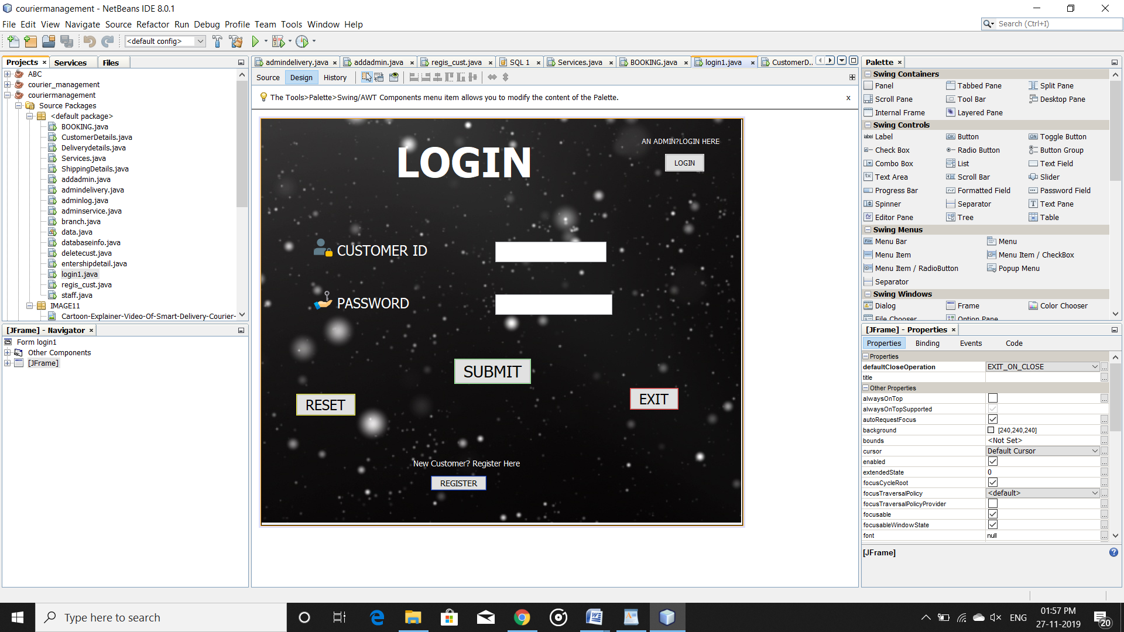

Figure 5.1 Customer Login

**CUSTOMER REGISTER**

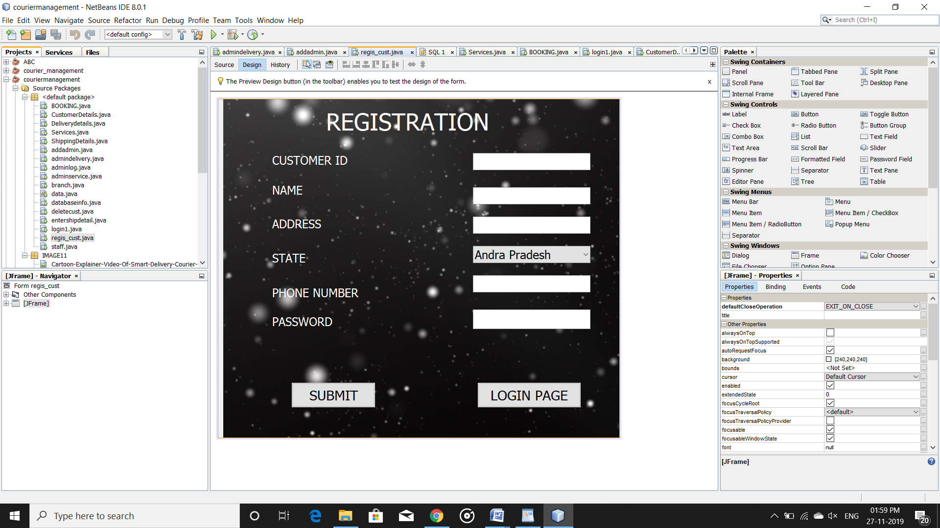

Figure 5.2 Customer Registration

**ADMIN LOGIN**

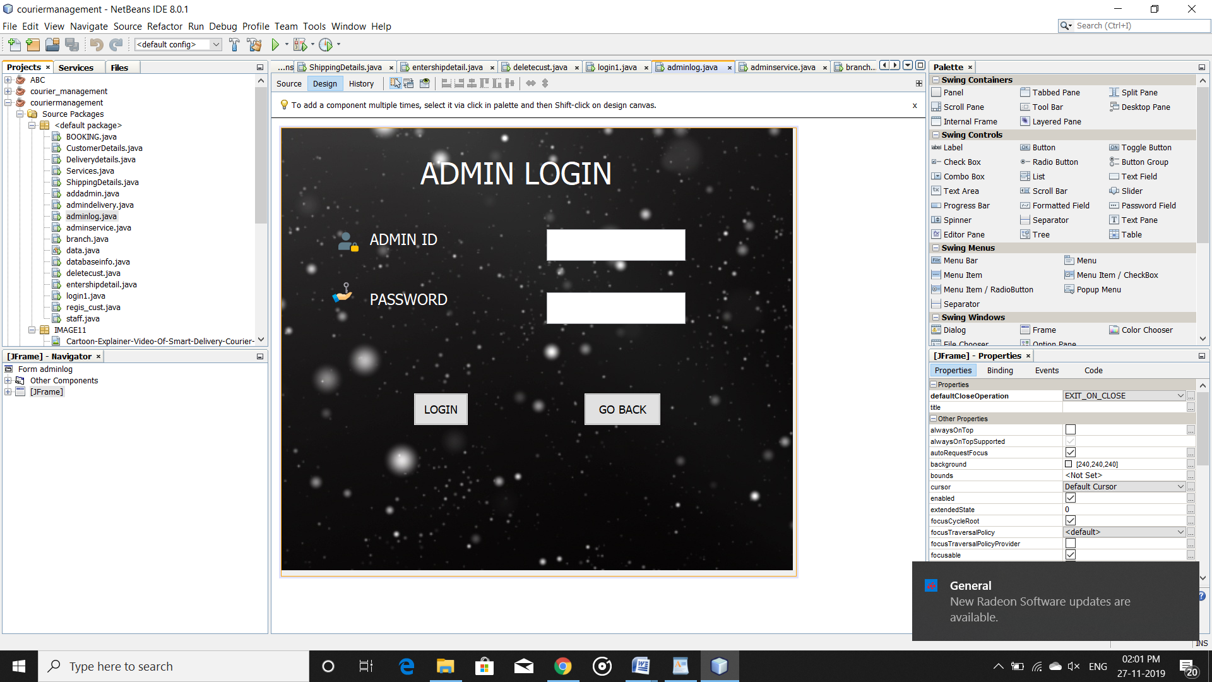

Figure 5.3 Admin Login

**ADMIN REGISTRATION**

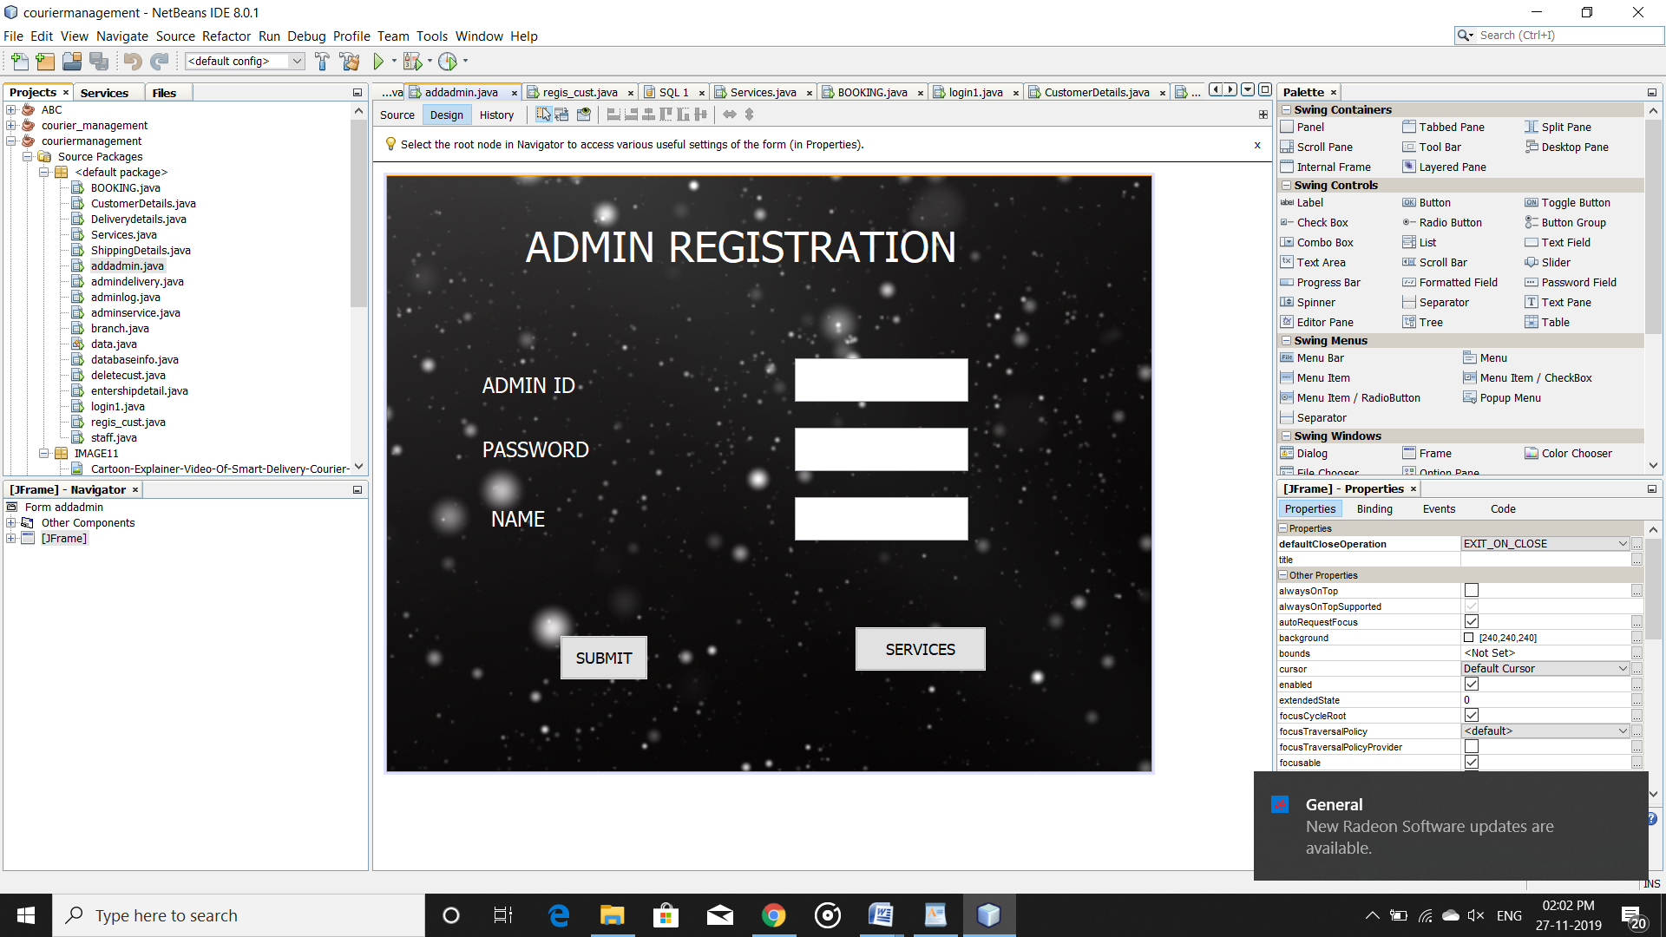

Figure 5.4 Admin Registration

**CUSTOMER SERVICES**

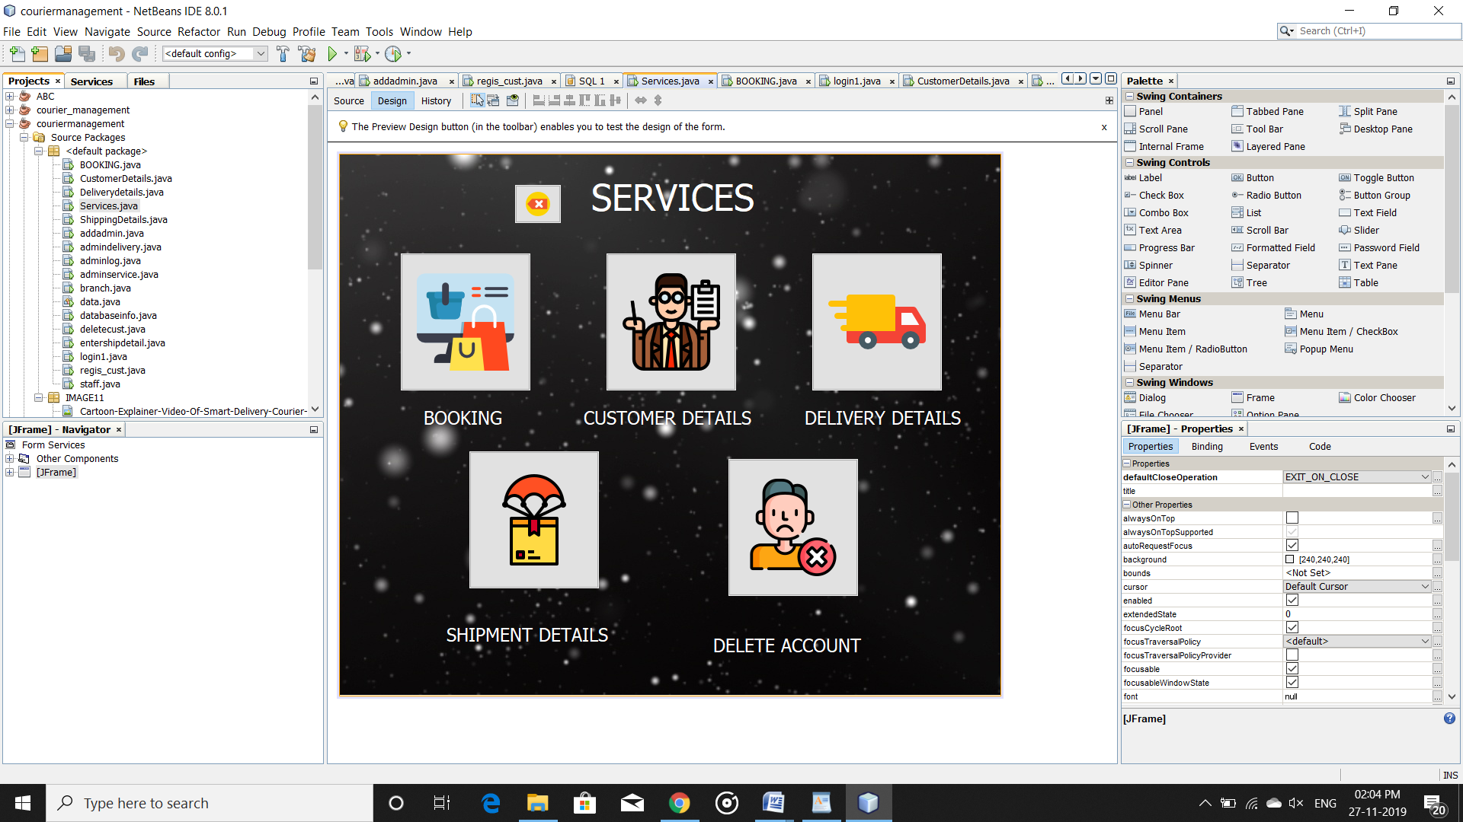

Figure 5.5 Customer Services

**ADMIN SERVICES**

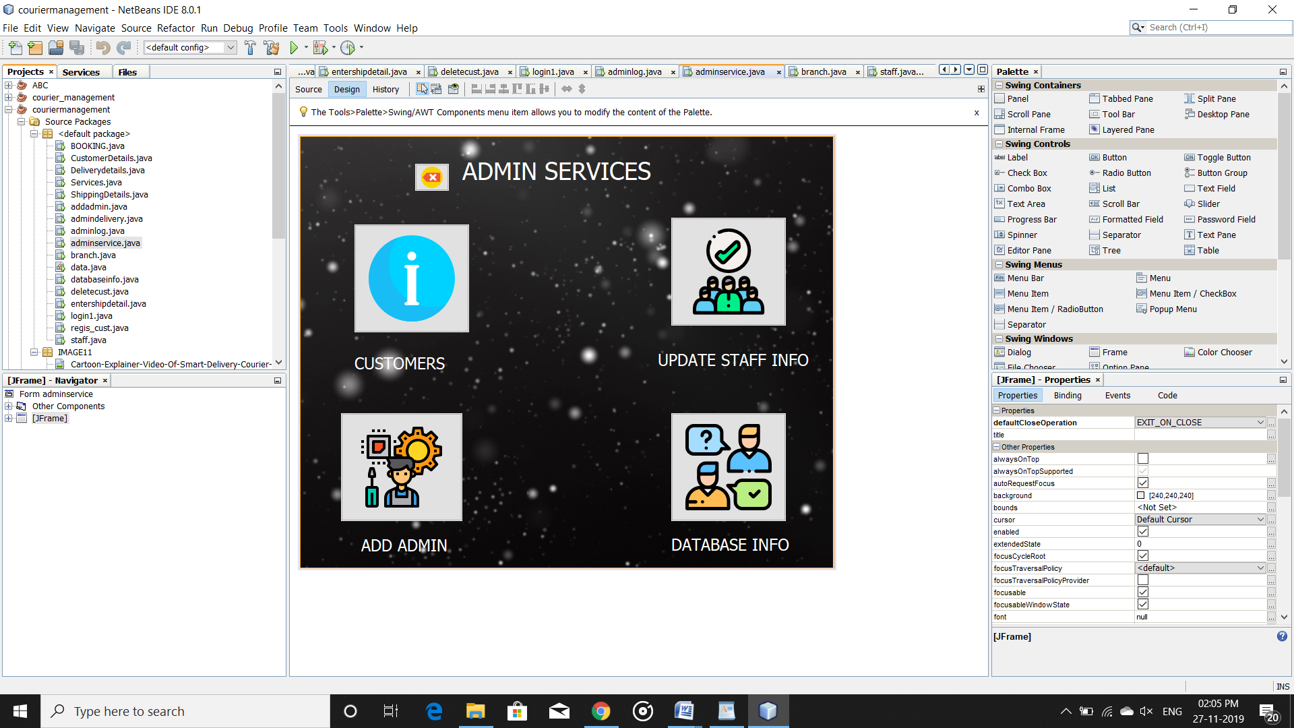

Figure 5.6 Admin Services

**CUSTOMER BOOKING**

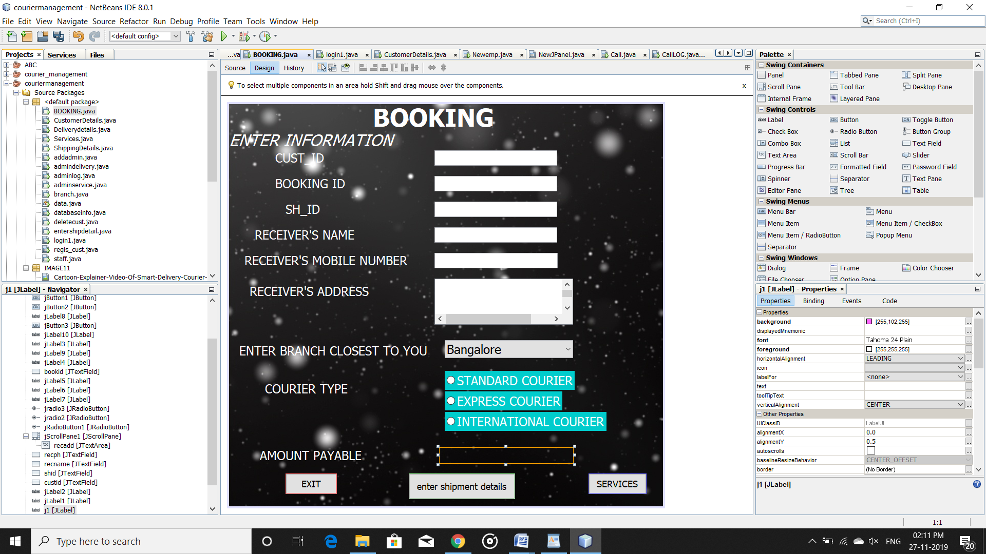

Figure 5.7 Admin Services

**CUSTOMER DETAILS**

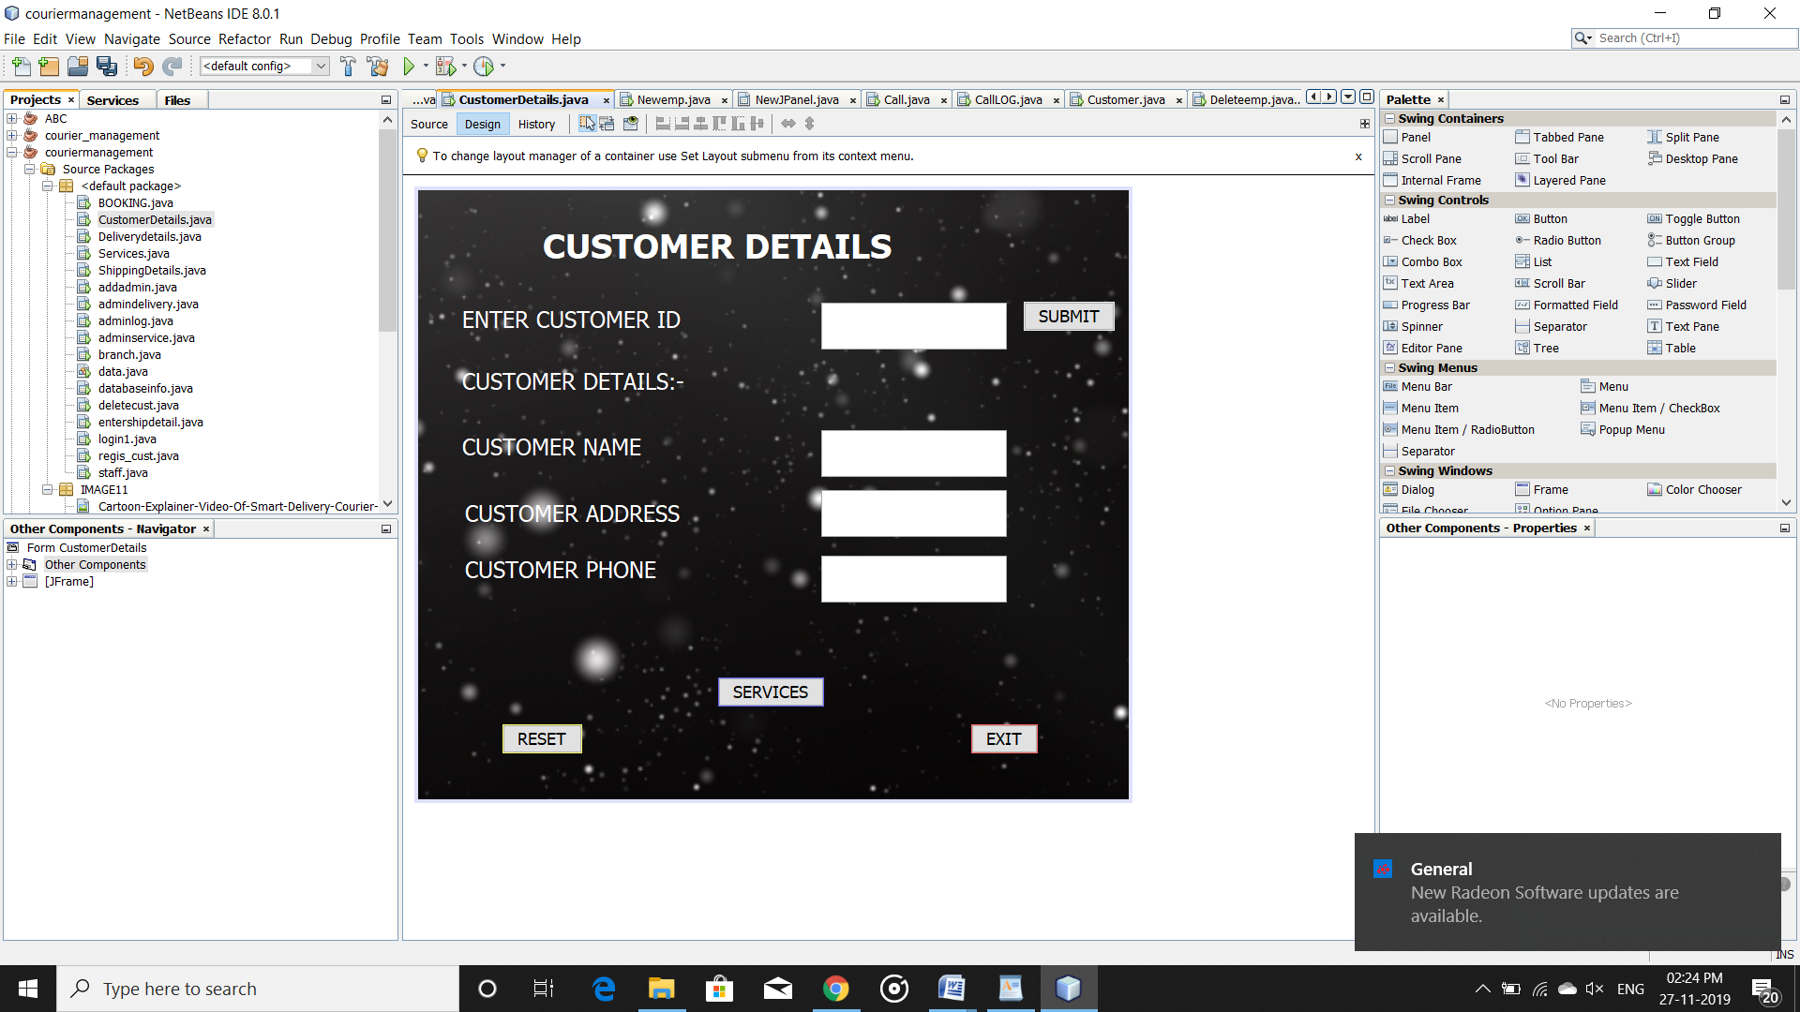

Figure 5.8 Customer Details

**DELIVERY DETAILS**

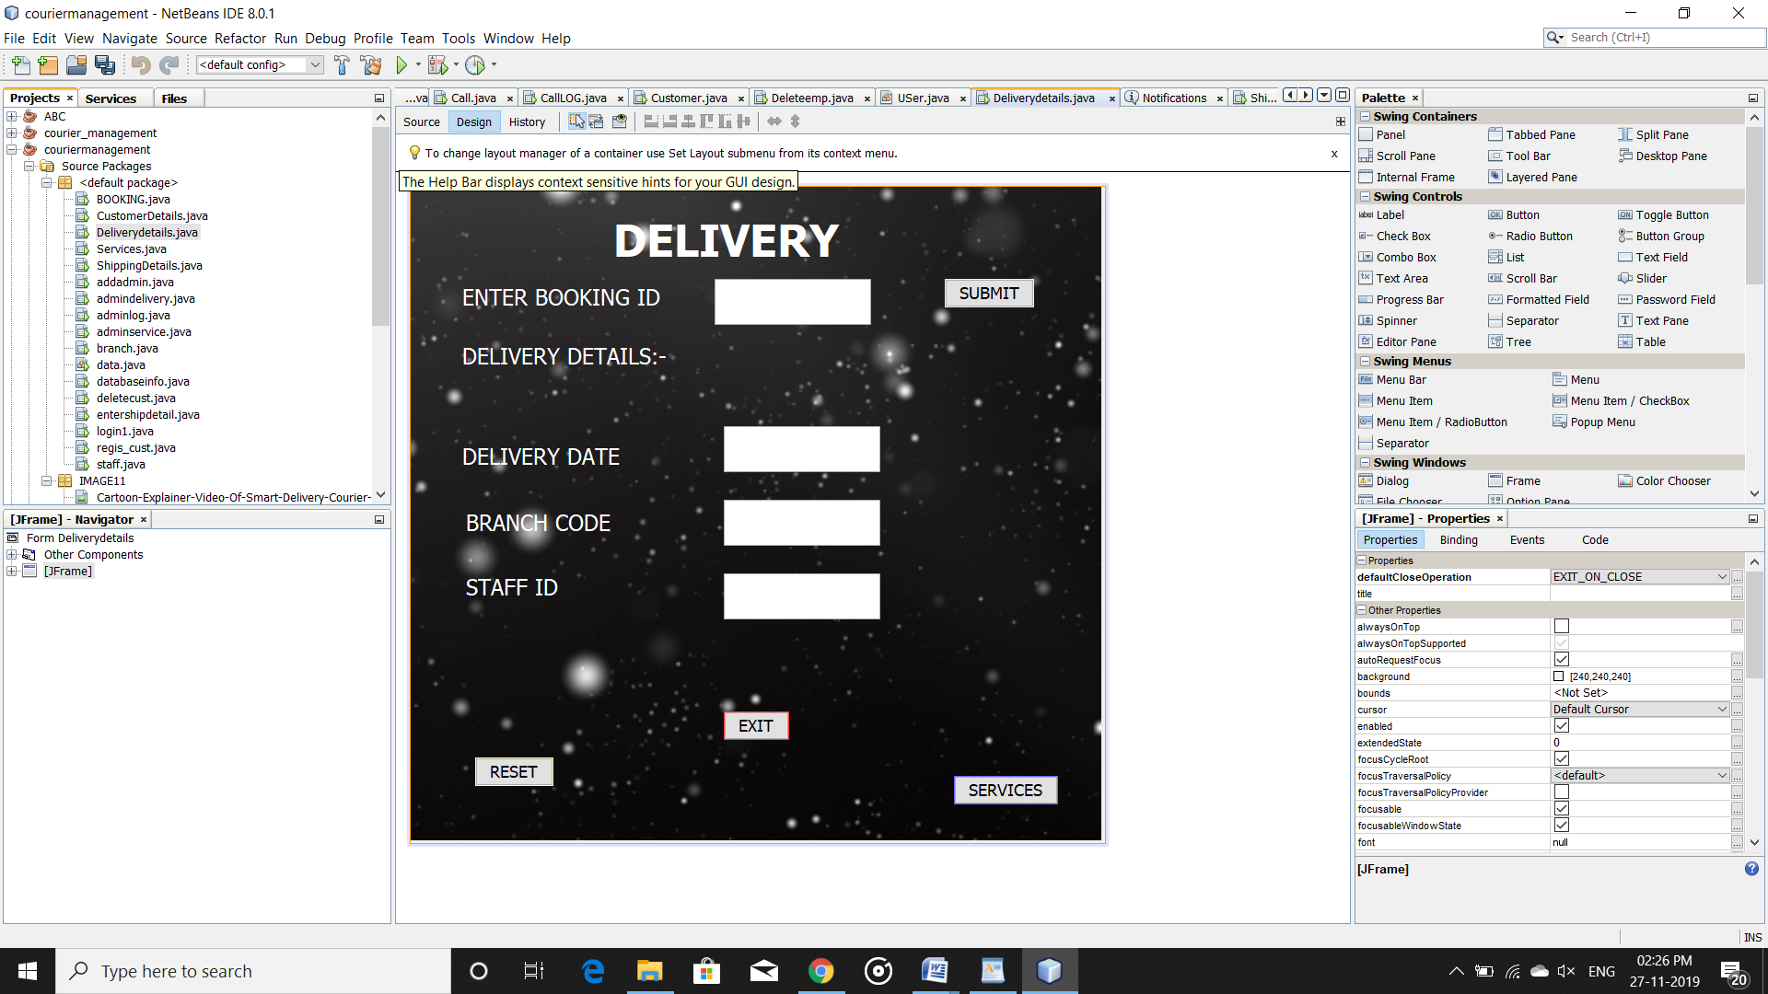

Figure 5.9 Delivery Details

**DELETE CUSTOMER**

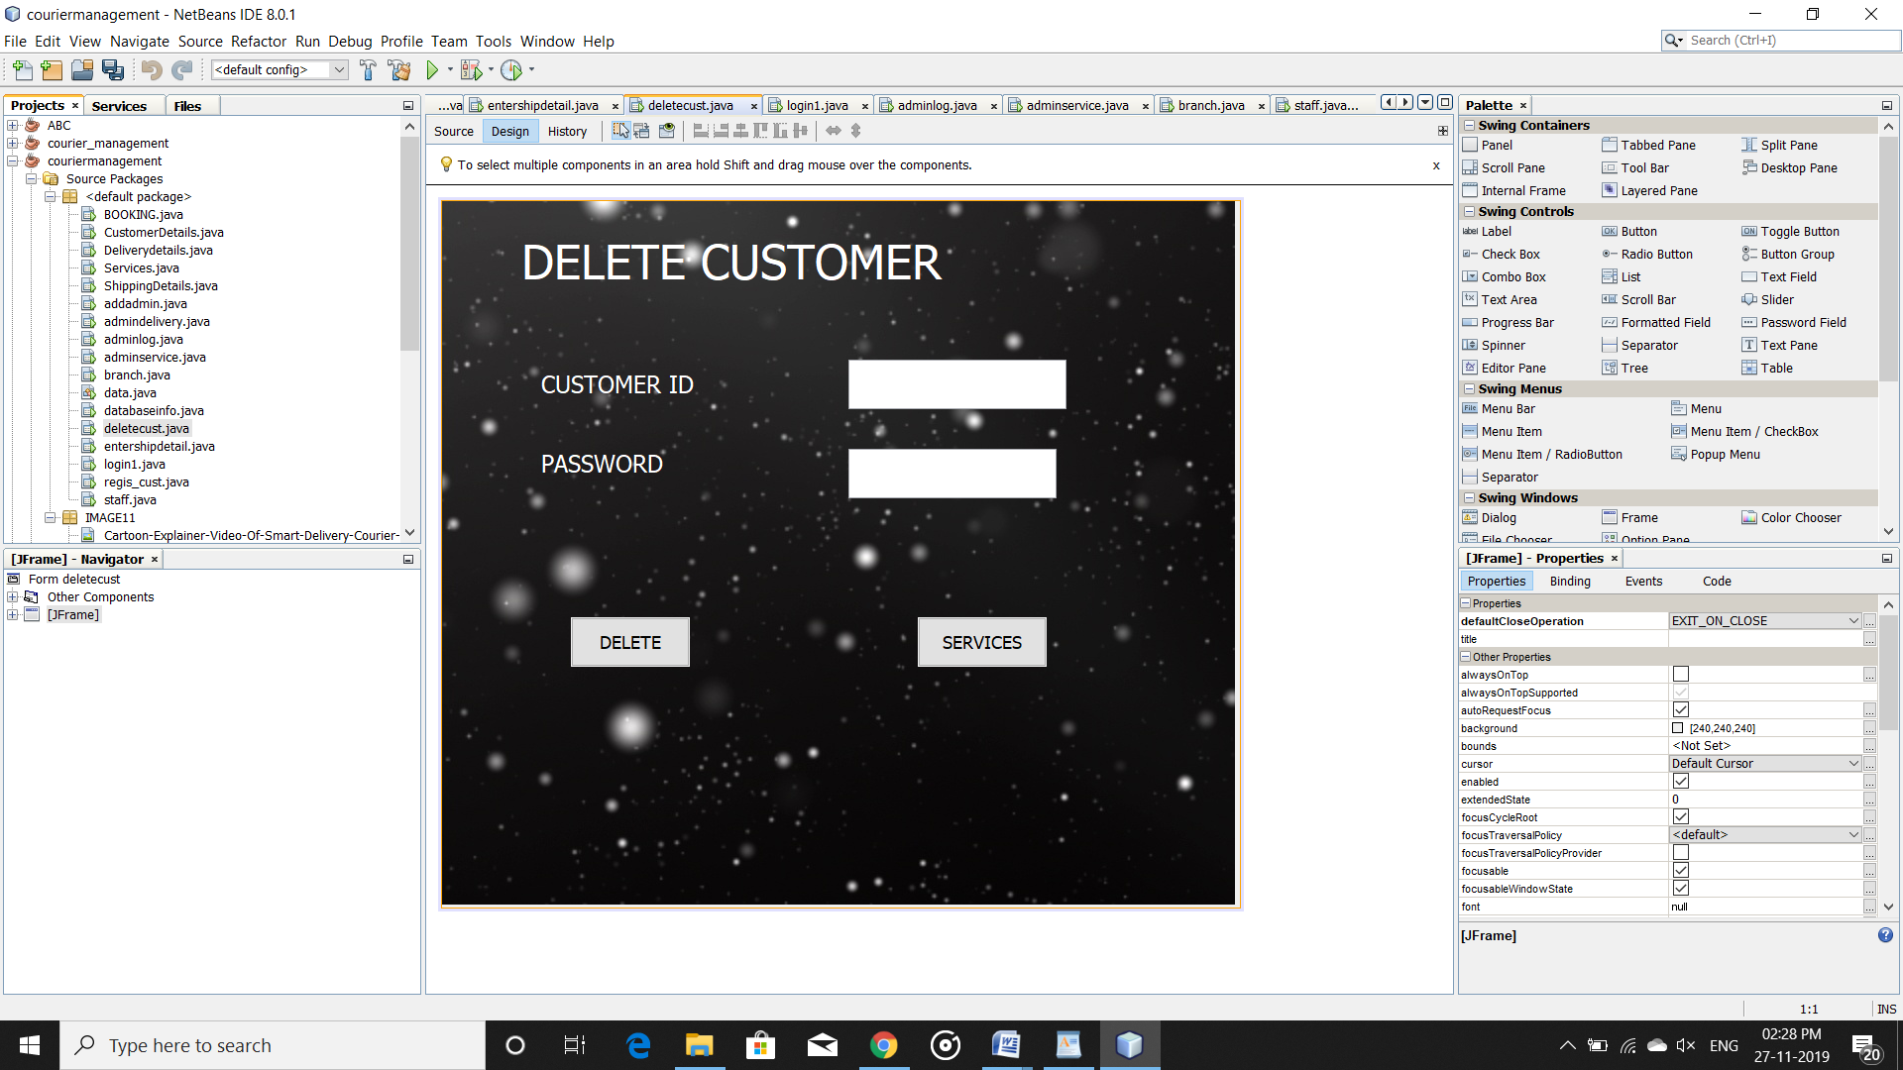

Figure 5.10 Delete Customer

**STAFF DETAILS**

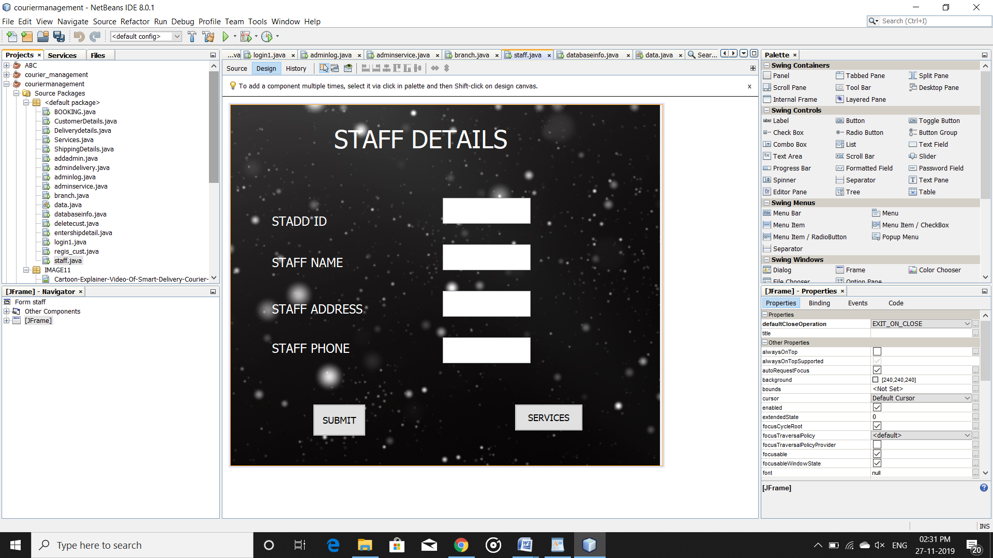

Figure 5.11 Staff Details

**DATABASE INFORMATION**

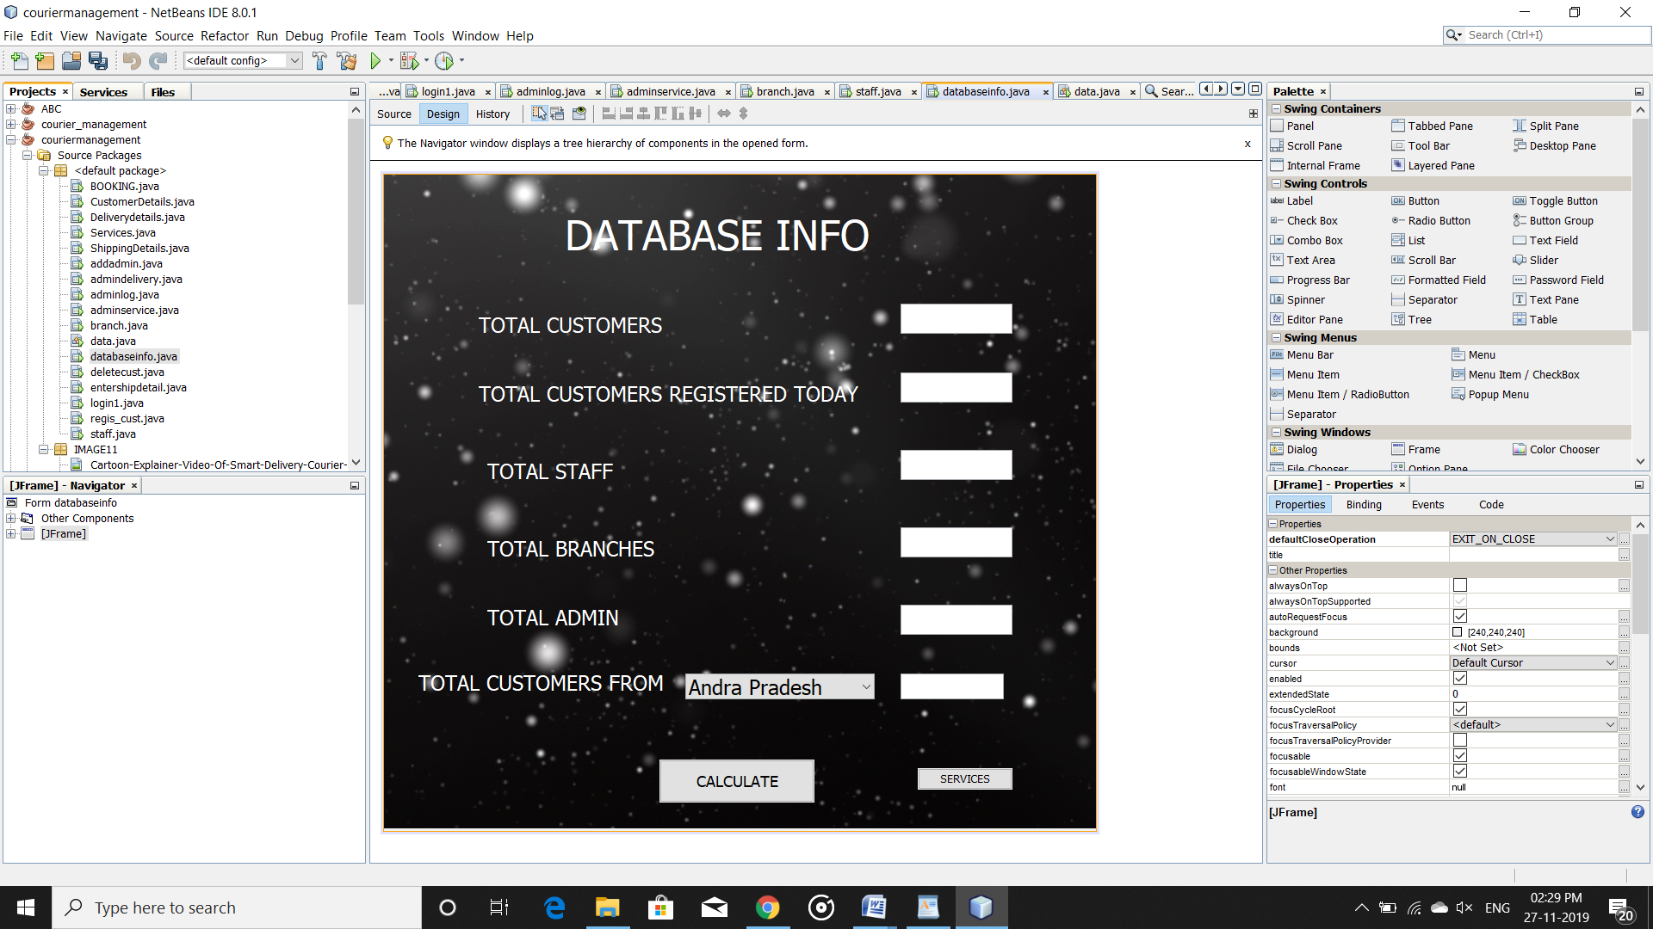

Figure 5.12 Database Information

**CHAPTER 7**

**CONCLUSION**

Courier management computerization is “the incorporate of appropriate technology to help administrator manage information. Technology is considered appropriate, when it utilizes the most abundant domestic resources and conserves capital and skilled personnel”. Nowadays, people are very busy and they don’t find much time to go to a dealer to get products. But they need to buy products. And most of the people are accessing Internet. Then why don’t we help them in searching & getting products online. Of course this is helpful for company & dealer also to improve the sales.

**REFERENCES**

* [1].Database system models,languages, design and application programming,RamezElmasri and Shamkhat B.Navathe, 7th Edition, 2017, Pearson.
* [2].Database management system,Ramakhrishnan, and Gehrke,3rd edition,2014,MC Graw Hill .
* [3].Silberschatz Korth and Sudharshan, database system concepts, 6th edition,MC Graw Hill,2013.
* [4].Coronel,Morris,and Rob,database principles fundamentals of design,implementation and management,Cengage learning 2012.